INDEX

Chapters Topics Page no.

CHAPTER 1: INTRODUCTION AND OBJECTIVE

1.1 Introduction

1.2 Project Profile

1.3 Objectives

1.4 Existing Manual System

1.4.1 Limitations of the Existing Manual System

1.5 Proposed System

1.5.1 Advantages of Proposed System

CHAPTER 2: REQUIREMENT ANALYSIS

2.1 Introduction

2.2 Software Requirement

23 Hardware Requirements

2.4 Training Requirement

2.5 Descriptions

2.6 Why C++?

2.7 What is Turbo C++?

2.8 What is Dev C++?

CHAPTER 3: FEASIBILITY STUDY

3.1 Introduction

3.2 Technical Feasibility

3.3 Economical Feasibility

3.4 Operational Feasibility

3.5 Conclusion

CHAPTER 4: CODING AND OUTPUT

4.1 Coding

4.2 Output

CHAPTER 5: CONCLUSION
5.1 Future Scope of the Project

5.2 Limitations

5.3 Security

5.4 Conclusion

CHAPTER 6: BIBLIOGRAPHY

6.1 Books

6.2 Websites

CHAPTER 1: INTRODUCTION AND OBJECTIVE

1.1 Introduction:

The project aims to develop a suite of four games using C+ programming language. These games include:

1. Cross 'N Knots Game: A regular tic-tac-toe game.

Each game emphasizes logical thinking, user interaction, and problem-solving, demonstrating the power and flexibility of C++.

1.2 Project Profile:

- Project Title: Game Suite in C++

-Platform: Windows/Linux

- Project Type: Application Software

-Category: Text-based interface

- Language: C++

1.3 Objectives:

A) To create engaging games that encourage problem-solving and logical thinking.

B) To develop user-friendly interfaces for seamless interaction.

C) To implement efficient algorithms for smooth gameplay.

D) To demonstrate the versatility and efficiency of C++ in game development.

E) To provide an entertaining and educational experience for users.

1.4 Existing Manual System:

Games traditionally involve manual methods or simple board games, which can be less interactive and engaging. The manual approach limits scalability and user experience.

1.4.1 Limitations of the Existing Manual System:

A) Lack of interactivity.

B) Difficulty in managing rules and scoring.

C) No personalized or automated gameplay experience.

D) Limited to physical play areas.

E) Time-consuming setup and teardown.

1.5 Proposed System:

The proposed system introduces a fully automated game suite built in C++, offering:

1. A streamlined and engaging user interface.

2. Automated game logic and scoring.

3. Enhanced interactivity and accessibility.

1.5.1 Advantages of Proposed System:

-Faster setup and gameplay.

-Error-free logic and scoring.

-User-friendly interface.

-Scalable and flexible codebase.

- Integration of logic, entertainment, and education.

CHAPTER 2: REQUIREMENT ANALYSIS

2.1 Introduction:

This chapter discusses the software, hardware, and training requirements for developing and running the game suite.

2.2 Software Requirements:

1. Usability: Intuitive and easy-to-use.

2. Performance: Responsive and efficient.

3. Scalability: Handles multiple users seamlessly.

4. Availability: Runs on various platforms.

5. Security: Protects user data and scores.

6. Maintainability: Easy to debug and upgrade.

2.3 Hardware Requirements:

- Minimum 4GB RAM, 500GB storage, dual-core processor.

- Compatible with desktops or laptops.

2.4 Training Requirement:

Basic understanding of:

-C++ programming.

- Logic building.

- Array and string manipulation.

2.5 Descriptions:

Each game employs specific C+ concepts, demonstrating the power of algorithms and data structures. Key features include:

1. Cross 'N Knots: Decision-making with conditions, loops.

2.6 Why C++?

- High performance and efficient memory management.

- Versatile and robust for game logic.

- Extensive library support.

- Cross-platform compatibility.

2.7 What is Turbo C++?

Turbo C++ is an IDE and compiler developed by Borland for C and C++. Although discontinued, it remains a classic tool for educational purposes.

2.8 What is Dev C++?

Dev-C++ is an open-source IDE for C and C++ programming, offering simplicity and flexibility for beginners and professionals.

CHAPTER 3: FEASIBILITY STUDY

3.1 Introduction:

Feasibility study evaluates the practicality and potential success of the proposed game suite. It encompasses technical, economic, and operational aspects.

3.2 Technical Feasibility:

Assessing whether the system can be implemented using existing technology and tools.

3.3 Economical Feasibility:

Evaluating cost-effectiveness and ROI of the project.

3.4 Operational Feasibility:

Ensuring smooth integration and user satisfaction.

3.5 Conclusion:

The proposed system is feasible in all aspects.

CHAPTER 4: CODING AND OUTPUT

4.1 Coding:

All the games are developed in basic cpp.

Codes of the games are given below.

A.

#include <iostream>
using namespace std;

char board[9] = {'1','2','3','4','5','6','7','8','9'};

// Display the board
void showBoard() {
cout << "\n";
cout << " " << board[0] << " | " << board[1] << " | " << board[2] << endl;
cout << "---|---|---" << endl;
cout << " " << board[3] << " | " << board[4] << " | " << board[5] << endl;
cout << "---|---|---" << endl;
cout << " " << board[6] << " | " << board[7] << " | " << board[8] << endl;
}

// Check win condition
bool checkWin() {
int win[8][3] = {
{0,1,2},{3,4,5},{6,7,8},
{0,3,6},{1,4,7},{2,5,8},
{0,4,8},{2,4,6}
};

for (int i = 0; i < 8; i++) {
if (board[win[i][0]] == board[win[i][1]] &&
board[win[i][1]] == board[win[i][2]])

return true;
}
return false;
}

int main() {
int choice;
char player = 'X';

for (int turn = 0; turn < 9; turn++) {
showBoard();
cout << "\nPlayer " << player << ", enter your move (1-9): ";
cin >> choice;

if (choice < 1 || choice > 9 || board[choice-1] == 'X' || board[choice-1] == 'O') {
cout << "❌ Invalid move! Try again.\n";
turn--;
continue;
}

board[choice-1] = player;

if (checkWin()) {
showBoard();
cout << "\n🎉 Player " << player << " wins!\n";
return 0;
}

player = (player == 'X') ? 'O' : 'X';
}

showBoard();
cout << "\n🤝 It's a draw!\n";
return 0;
}
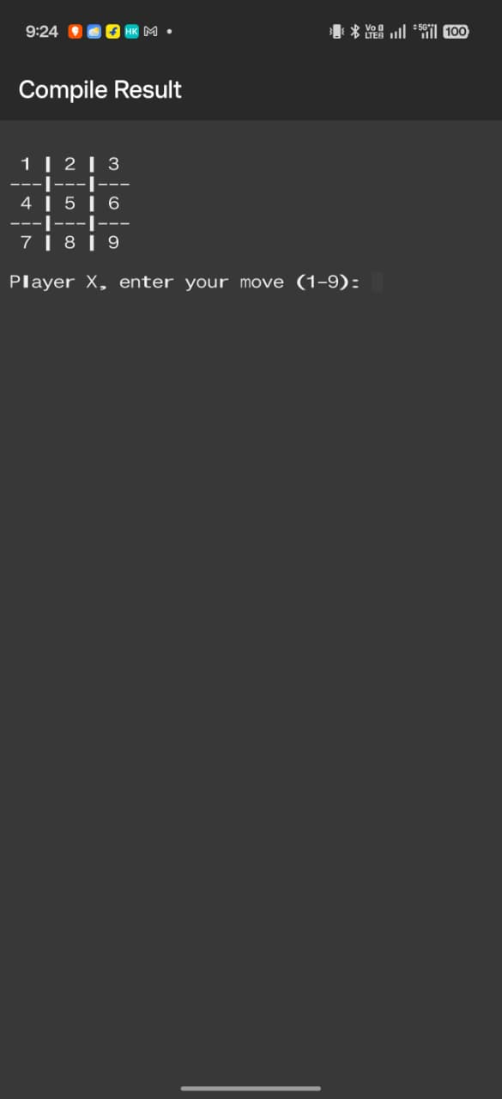5.1 Future Scope of the Project:

- Enhanced graphics and sound.

- Multiplayer options.

-Mobile platform adaptation.

5.2 Limitations:

-Text-based interface.

-Limited Al complexity.

- Basic scoring mechanisms.

5.3 Security:

-Data validation and input handling.

-User authentication for multiplayer features.

5.4 Conclusion:

The project successfully demonstrates the versatility of C++ through engaging games.

CHAPTER 6: BIBLIOGRAPHY

6.1 Books:

- Jeffrey M. Cogswell, "C All-in-One For Dummies"

-Herbert Schildt, "C++: The Complete Reference"

- Bjarne Stroustrup, "Programming: Principles and Practice Using C++"

- Josée Lajoie and Stanley B. Lippman, "C++ Primer"

6.2 Websites:

-https://stackoverflow.com

-https://www.skillarger.com/

